Aryan Sai Venkat M

230701040 CSE A

EXP NO:4a Employee Average Pay

# PROGRAM

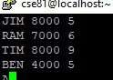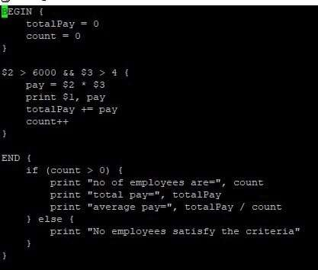

# OUTPUT

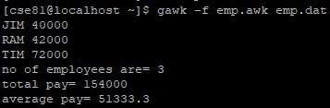

EXP NO:4b Results of Examination

1

# PROGRAM

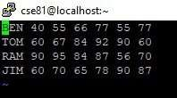

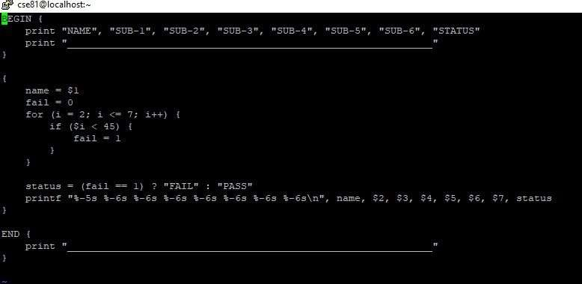

# OUTPUT

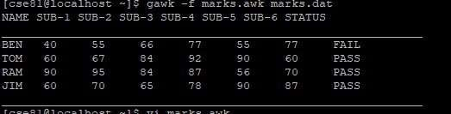

2